Entertainer Data Analysis

# Wireframe Documentation

## Homepage

As per for analysis we dived the analysis in three different section:

* 1. At what age entertainer are able to gain stardom in their life .

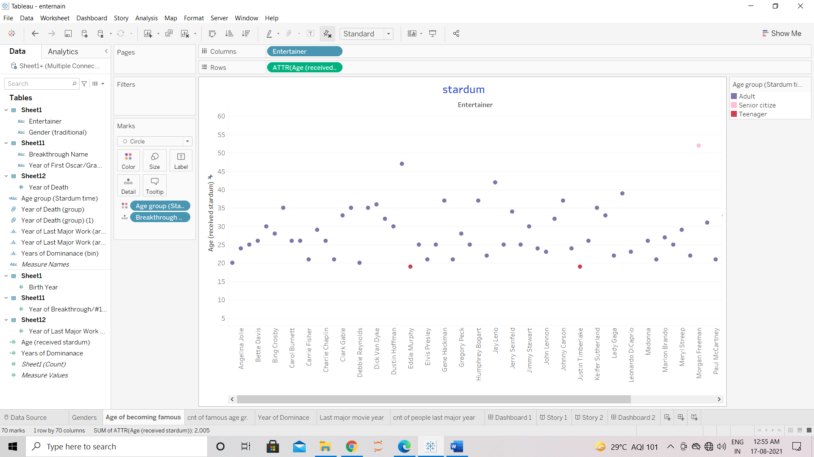

1.2> Number of entertainer belonging from different age group .

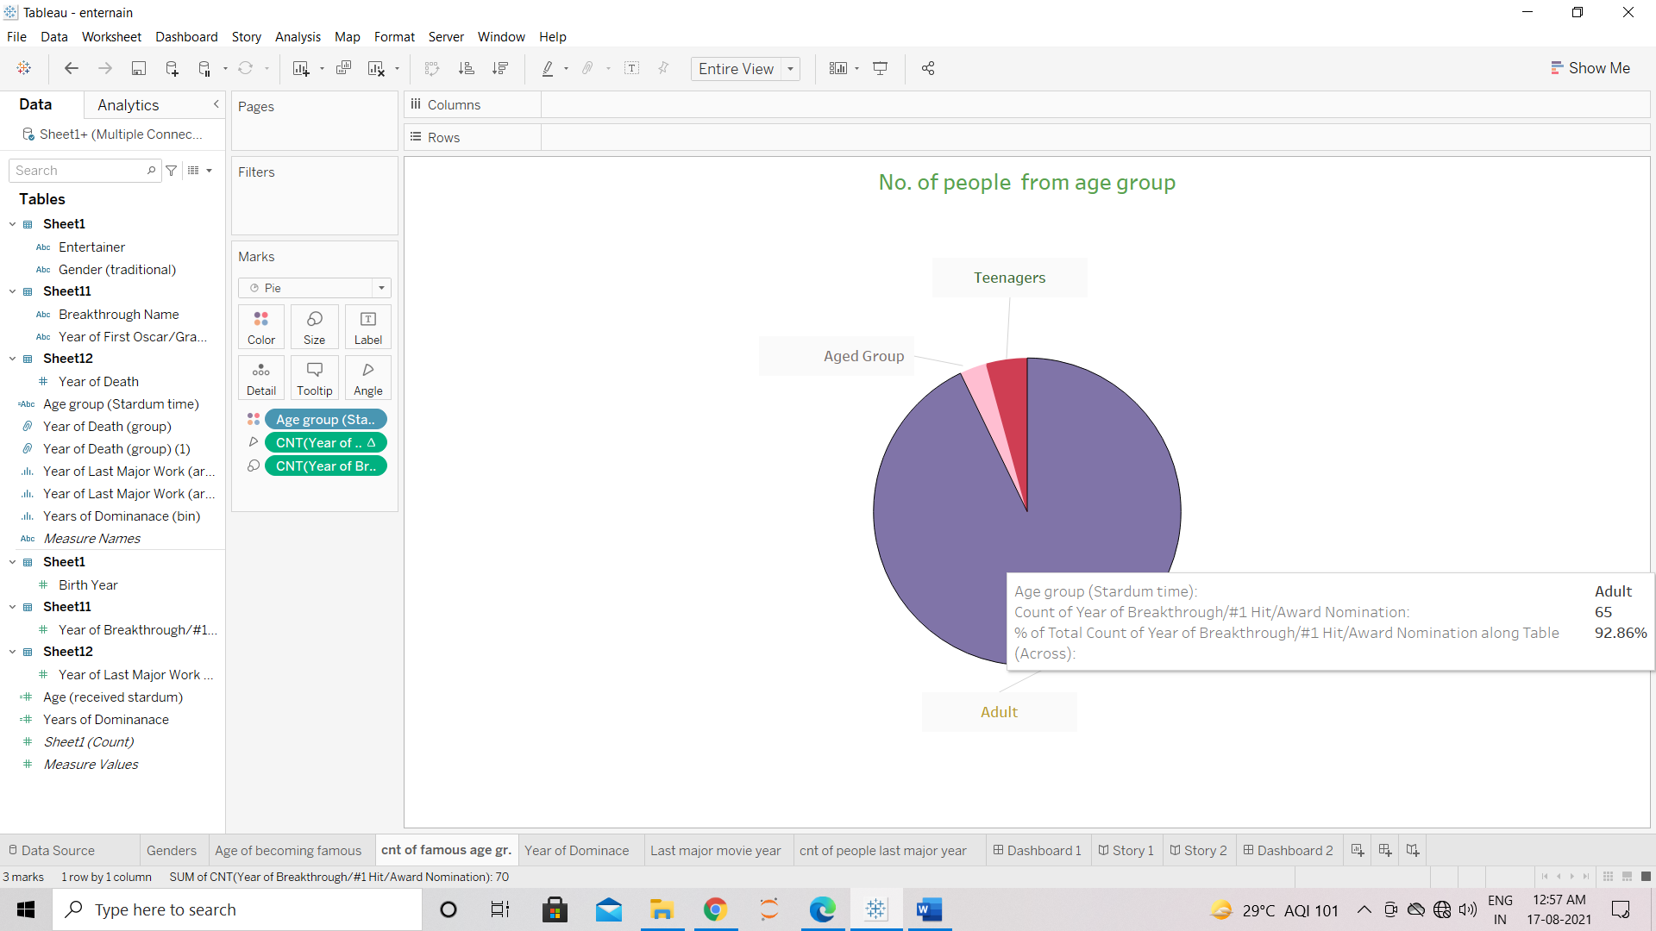

2> long entertainers are able to maintain there dominance in industry

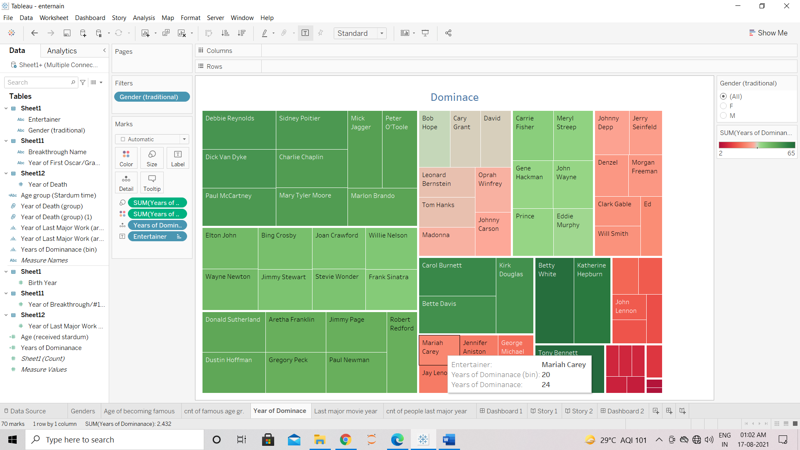

3.1> Last year when entertainer are seen as major part.

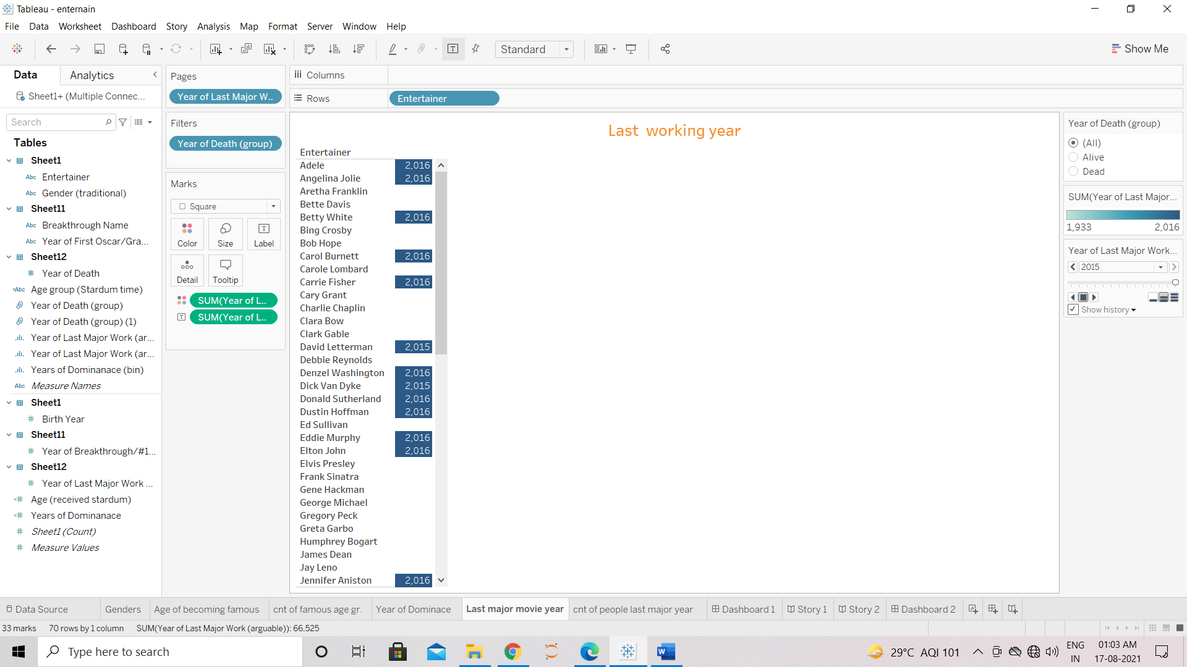

3.2> number entertainer are ending there career in specific year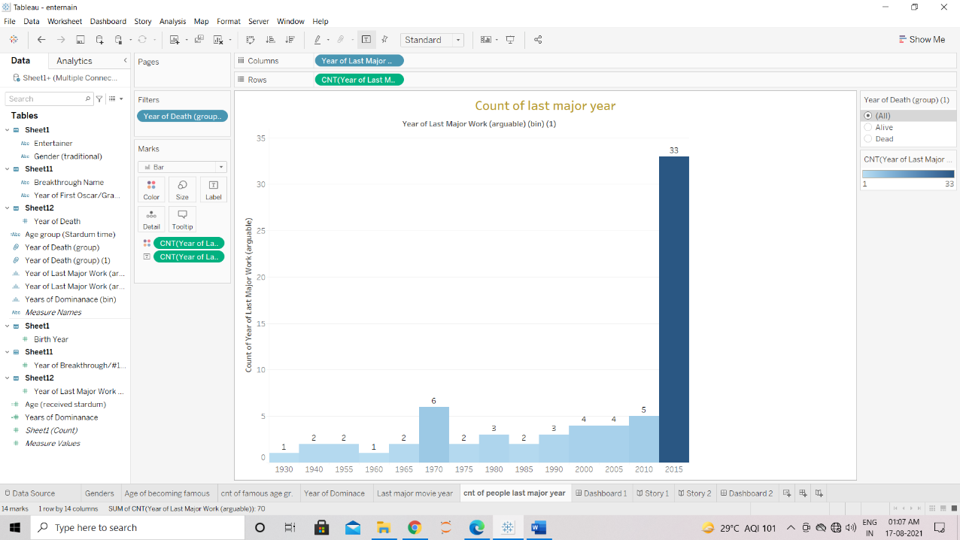.

Finally which entertainer can be consider best entertainer from given data .

